CRM ERP software Roadmap UPDATE


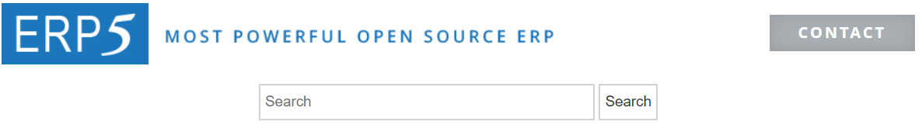
CRM Welcome Home to CRM nErgy AI Studios

[ CRM nErgy Home ] ⫷ ( Click Button To Bring You Back To The CRM Home )

Branding and Customization Client Management Core CRM Features Communication Tools

Additional Functionalities Support and Resources Industry Territory

AI Marketing User Access Controls AI Content Studio AI Video Agent Creates

CRM System

Branding and Customization Client Management Core CRM Features Communication Tools
-Custom Domain -Client Portals -Contact Management -Email and SMS Integration
-UI Rebranding -Multi-Tenant Management -Client Data -Reporting and Analytics
-Email Notifications -Sub-Account Provisioning -Billing and Invoicing -Mobile App
-Branding and Customization -Lead and Pipeline Management
-Sales Automation
-Communication Tools

Additional Functionalities Support and Resources Industry Territory
Project Management [ ERP] -Help Documentation
Tutorial
-Trouble Shooting
-FAQs
-Customer Support

AI Marketing User Access Controls AI Content Studio AI Video Agent Creates
-Landing Page Creator AAI Muzik Hit Studio Onboarding Videos
AAI Real Talk Tutorial Videos
AI Audio Writer How It Works Videos
AI ConTalk Explainer Videos
AI Film Maker Infographic Creations
AI Image TalkR Training Videos
AI Logo Generator Product Ad Videos
AI Photo Life Product Explainer Videos
AI Video Crew Social Media Videos
AI Visual Workflow Short Story Videos
AI VoiceX Change Security & Data Protection
AAI BIG Movies Lab Redesign any Website
Train AI to Speak Logos
2D, 3D, Avatar, Characters

CRM Project Management will have restricted features to reflect CRM features; End-users can always upgrade to the ERP or both systems.

CRM nErgy ERP System

Purchase Order Management/ Reporting and Sales and Order
Project Management Industry Procurement Analytics Management

Human Resources Supply Chain Finance and Customer - Territory
Management Accounting Relationships

Manufacturing Additional Features

CRM nErgy ERP System

Purchase Order Management/ Reporting and Sales and Order
Project Management Industry Procurement Analytics Management
- Project Planning - Supplier - Data Visualization Tools - Customer relationship
and Execution Management - Custom Report Generation Management (CRM)
- Time and - Invoice Processing - Business intelligence - Pricing and discount
Expense Tracking - Spend Analysis Dashboards Management
- Budgeting and - Performance - Sales Analytics
Forecasting Metrics Tracking - Order Processing and
- Resource Management Fulfillment

Human Resources Supply Chain Finance and Customer - Territory
- Employee Data Management Accounting Relationships
Management - Stock Level Tracking -Accounts Payable
- Payroll Processing - Warehouse and Receivable
- Recruitment and Management -Budgeting and
onboarding - Inventory Optimization Forecasting
- Performance - Demand forecasting -Financial Reporting
Management and Compliance

Manufacturing Additional Features
Production Planning - Automation
and Scheduling - Integration
- Quality Control - Data Analysis
- Bill of Materials - Compliance and
Management Risk Management
- Resource Allocation

